Design and Implementation of Blood Pressure Measuring and Oximetry (Android Based)

Aciek Ida Wuryandari*1 and Herwin Suprijono#2

\**School of Electrical Engineering and Informatics*

*Bandung Institute of Technology, Ganesa Street 10, Bandung 40132, Indonesia*

*#Electrical Engineering Department, Faculty of Engineering*

*Dian Nuswantoro University, Jln. Nakula I No. 5-11, Semarang, Indonesia*

[1aciek@lskk.ee.itb.ac.id](mailto:1aciek@lskk.ee.itb.ac.id)

[2herwin.suprijono@gmail.com](mailto:2herwin.suprijono@gmail.com)

Abstract**— Mobile health or better known as m-health is the use of mobile devices for medical practices. M-health technology involving mobile telecommunications infrastructure in providing medical services to patients. Mobile technology has developed very rapidly, where the cost of mobile devices getting cheaper, so that mobile devices become an essential tool of communication and information technology.**

**Android devices is a major preoccupation in the development of the general computing world. Android is a comprehensive device, because Android based Linux operating system that has the ability to regulate the use of the device, memory and process.**

**The device is designed to measure oximetry and blood pressure. Communication between the device and a mobile phone using Bluetooth communication is embedded in a mobile phone that uses the Android operating system 2.3.3. The function of this mobile phone to display the data after the measurement, the transmit data that has been measured by SMS, e-mail and a local database. The device is designed to be used personally or to support the use of the hospital.**

***Keywords*— m-health, bluetooth, oximetry, blood pressure, Android.**

1. INTRODUCTION

Mobile computing and mobile devices, has changed the relationship between humans and computers, and introduced a new form of communication based on context. According to Figueiredo [1] a new form of communication allows people to interact easily with the object, computer, environment and others. Technological progress is a significant development of the existing computing paradigm, in which users need to explicitly interact with the system to achieve the desired results.

Mobile health or better known as m-health is the use of mobile devices for medical practices. M-health technology involving mobile telecommunications infrastructure to provide medical services for patients. Mobile technology has developed very rapidly, where the cost of mobile devices getting cheaper, so that mobile devices become an essential tool of communication and information technology.

As shown in [3], tens of millions of citizens who have never had regular access to a fixed-line phone or a computer, but now the mobile device is used as an everyday tool for communication and data transfer. M-health can be seen as an access point to capture and incorporate the information collected, providing information to health clinics and health, m-health involves digitizing patient records and creating a standard electronic system to access patient data.  
For a developing country like Indonesia where the standard of living is low, less medical and health infrastructure are scarce, the use of cell phones can be used for health care services that improve the quality of people's lives.

II. BACKGROUND

M-health technology along with electronic systems has changed the profile of medical services. For example, m-health technologies have the potential to replace 5% of hospitalizations, 5% in home visits by nurses (nursing homes), and 20% of home visits by health workers, translating into economic use of the time and money for patients and health professionals [4].

The advantage of m-health, including the possibility of establishing a direct relationship between health professionals and patients to provide efficient medical assistance, so as to save time, especially for the rural population. In addition, patients can follow up with their health recovery has great access to the information that they have suffered disease [5].

Advances in telecommunications and information technology, has enabled the type of medical services through mobile telecommunications infrastructure. By this time everyone was able to easily have access to the phone so that people can easily connect electronically. Researchers have started to develop healthcare solutions by utilizing communication technologies.

The development of the m-health can be useful to save lives or at least improve the quality of life, especially for people suffering from chronic diseases. In the tool will be designed here combines the two functions, namely blood pressure devices and oximetry. Arterial blood pressure was chosen because it is a disease that affects many people in the world, and the application of oximetry selected as the equipment involved is usually too expensive, so a prototype tool that might contribute to lower costs so that more people have access to this technology.

The purpose of this study was to design a prototype medical device that can measure blood pressure and oximetry which can be read by Android smartphone with bluetooth data communication.

Limitations of this study there are some limitations to the results of the study remained consistent with the objectives are as follows.

1. Medical equipment is designed to measure blood pressure and oximetry.
2. Minimum operating system on smartphones using Android 2.3.3.
3. Data Communication with smartphone device medical device via bluetooth.
4. Not implementing data security systems.

III. ANALYSIS AND SYSTEM DESIGN

The scenario is expected to be expected from the study are as follows.

1. Patients were discharged from the hospital (outpatient) and the doctor wants to monitor certain distance measurement. Patients taking measurements and then sends measurement data to physicians via SMS / text message or email.
2. Nurses walk (Travelling nurse) who visited some of the patients, whether the measurements for each, and then at some point to send all the data to the central system (hospitals or physicians). The application can also be done on his remote areas that still lack of doctors.
3. Patients taking measurements independently to determine health data such as blood pressure, oximetry, and as her weight. Patients can save measurement result data and send that data to a doctor or hospital.

Block diagram of the system to be built with this study as follows.



Fig.1 Block diagram of the system design

**3.1 Design of Hardware**

Designing hardware consists of several blocks as described below.  
  
3.1.1 Sensors and SpO2 Measurements Insrumentation  
 Pulse Oxymetri sensor consists of superbright Red LED with a wavelength of 660 nm and Infra Red LED with a wavelength of 940 nm and there is a photodioda to receive the light absorbed. The following figure shows the sequence of pulse oxymetry sensor.



Fig.2 Pulse oxymetry sensor circuit

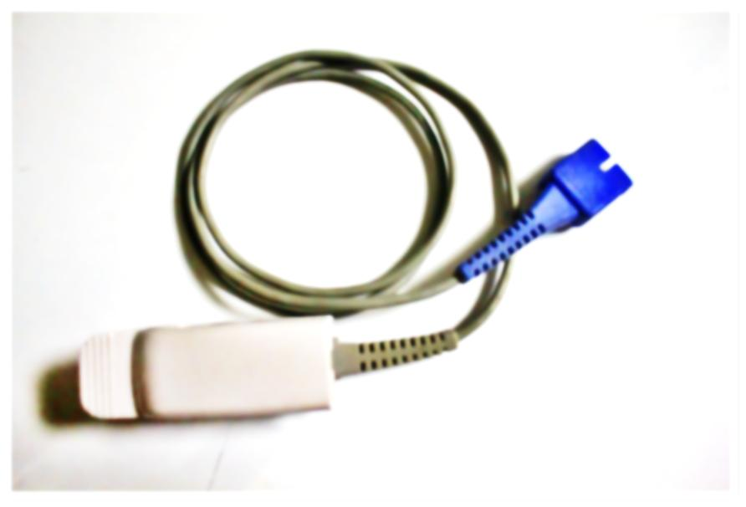

Fig. 3 Pulse oxymetry sensor

For pulse sensor readings oxymetri early - first Red LED and Infra Red LED pulses were given in Fig. 4.

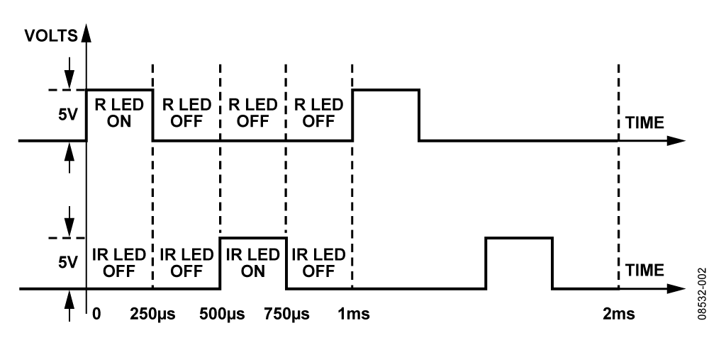

Fig. 4 Provision for powering LED pulses Red and Infra Red LED [13]

After both LEDs are in turn then placed on the fingertips, the next step is reading the light beam that penetrates or passes blood vessels when the heart pumps blood, the blood volume in the fingertips will increase the beam of light is partially absorbed and partly transmitted, and then reading light absorbed is proportional to the amount of bound O2 concentration in the blood. Then from the sensor will go into the amplifier and then enter into an ADC (Analog to Digital Converter) and will be processed internal microcontroller to send via bluetooth.

The oximetry instrument circuit can be seen in Fig. 5. The circuit is divided into several sections. The first part serves to detect the light received by the photodiode. The set used is a trans-impedance amplifier that serves to strengthen the flow and convert current to voltage.



Fig. 5 Oximeter instrument circuit

3.1.2 Blood Pressure Module

In this work, OMRON equipment used to measure blood pressure. OMRON module is controlled from the microcontroller module to start the measurement by activating the pump to fill the air in the cuff is the sensor reads the air pressure in the cuff, as well as detect the blood flow pulse, the pulse is later read as systole and diastole. Once finished pumping gas to a certain pressure, the pressure is determined by blood flow pulsation is not detected, if the pulse is not detected, the pump stops pumping cuff. After that the air coming out slowly. Systole is determined from the first pulses when the air pressure in the cuff is reduced gradually. Diastole is determined from the last pulsation can still be detected by the sensor.

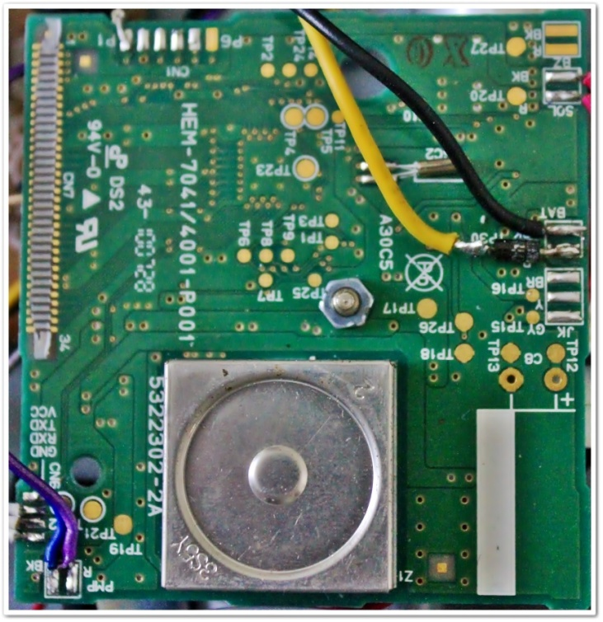

Fig. 6 Blood Pressure Sensor OMRON SEM-1

After the measurement is complete the module will send the code by serial measurements with baud rate 9600. Code will be read by the microcontroller module to translate and then sent to the Bluetooth module.

3.2.3 Bluetooth Module [14]

The function of the Bluetooth module is for data communication from the microcontroller module with android smartphone. Communication between Bluetooth module with microcontroller via serial communication module.

Specifications owned by this module are:

* Bluetooth chip: CSR BC417143
* Bluetooth protocol: Bluetooth Specification v2.0 + EDR
* USB Protocol: USB v1.1/2.0
* Operating frequency: 2.4 ~ 2.48GHz unlicensed ISM
* band Modulation: GFSK (Gaussian Frequency Shift Keying)
* Power transmission: ≤ 4dBm, Class 2
* Transmission distance: 20 ~ 30m in free space
* sensitivity: ≤-84dBm at 0.1% BER Transfer rate: Asynchronous: 2.1Mbps (Max) / 160 kbps; Synchronous: 1Mbps/1Mbps
* Facility Security: Authentication and encryption
* Support profiles: Bluetooth serial port
* Serial port baud rate: 4800 ~ 1382400 / N / 8/1 default: 9600
* Power supply: +3.5 V ~ +8 V DC and 3.3V DC/50mA

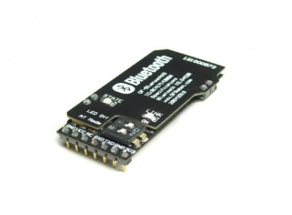

Fig. 7 Bluetooth Module DFRobot V3 [14]

Module microcontoller in this study serves to do things like the following.

1. Retrieving data from the amplifier module oximetry which still form an analog voltage and convert them into digital data using analog to digital (ADC) which is owned by the internal microcontroller. The data were processed to obtain SpO2 values​​.
2. Enable blood pressure module and then read data via serial communication of measurement results. Code is sent from the blood pressure module translated by microcontroller and sent to the Bluetooth module.



Fig. 8 The circuit of module microcontroller ATMEGA 128

1. Receiving orders from android smartphone and send the data from the measurement results oximetry and blood pressure to the Bluetooth module via serial communication.

Designing ATMEGA 128 microcontroller module associated with supporting modules, as shown in Fig. 8.

**3.2 Design of Android Applications**

In making this takes some of the support that is needed hardware, software and users (brainware).

a. Hardware  
 To support the creation of applications, it takes a computer used to run the Android emulator. Computers that are used have the following specifications.  
1. IBM ThinkPad R61.  
2. Intel Core2Duo T7100, 1.8 GHz.  
3. 2 GB of RAM.  
4. 80 GB hard drive.  
5. Operating System Windows 7.

As for the simulation on mobile phone devices required with the following specifications.  
1. Samsung ACE  
2. Processor 800 MHz.  
3. Screen resolution of 480 x 800 pixels.  
4. Internal memory of 512 MB RAM.  
5. Android OS 2.3.3.  
6. GSM/3G/WLAN.

b. Software  
 Preparation of system modeling, programming and simulation requires some software as follows.  
1. Java SE Development Kit version 1.6.0.  
2. Android Software Development Kit (SDK).  
3. Indigo Eclipse IDE 3.7.  
4. Android Development Tools.  
5. Database SQLite Manager.  
6. Microsoft Visio 2007.  
7. StarUML.

c. User/brainware  
 User applications TraiNFC and Trainductor require some user criteria as follows.  
1. Users familiar with applications that operate on the Android operating system  
2. Users accustomed to using applications that operate on the Android operating system  
3. Users can use a mobile phone that has bluetooth communication.

3.2.1 Analysis of Users  
 In the Android apps are designed there are some features that can be accessed by the user (user) as follows.  
a. To measure blood pressure;  
b. SpO2 measurements;  
c. record the measurement results;  
d. send the measurement results to a physician or medical personnel.

3.2.2 Design System  
 General description of the design of this application can be seen from the flowchart below.



Fig. 9 The planning application diagram

3.2.3 Interface Design

In android application design required an interface (interface). The design of the interface consists of displays that will be displayed to the user as well as the display when the user performs a certain action.

a. Home Interface

The main page is displayed immediately when the application is run. On this page the data that patients should input Name, Age and Gender.

b. Interface Blood Pressure

Blood Pressure is the interface design interface if a user selects the menu for the measurement of blood pressure. Once the button is enabled then the blood pressure module will work and display the measurement results on-screen Android smartphone is data systolic, diastolic and pulse rate. On the menu there are options to save data by pressing the save measurement data, SMS and E-mail.

c. Oximetry interface

Oximetry Interface is designed interface if the user selects the menu for the saturation of the blood. Once the button is activated the oximetry module will work and display the measurement results on-screen Android smartphone is the data heart rate and blood oxygen. On the menu there are options for this menu there is an option to save the data by pressing the save measurement data, SMS and E-mail.

d. Interface Bluetooth connection

Prior to the measurement of the Android smartphone must be connected to the device.

3.2.4 Database Design

In the Android application designed patient data is saved to a database .. The use of additional data base will be used MySQL for data storage that is online. Here is the design of a data base that will be applied to this application.  
This database will be used to store data measurements patients. This database system will be applied online, by way of storing data that will be used to perform measurements of activity in a patient's condition to the server that is connected to the local network. In addition the data base will be accessible to find records of the patients.  
In this database system will be stored the data name, age, gender and outcome measurement tools.

IV. iMPLEMENTAtion AND TESTING

**4.1 Implementation of Application**

4.1.1 Implementation of Interface

The application interface is implemented on smartphones Samsung ACE. Interface implementation of each menu and sub​​-menu tested at the testing stage. Application interface for the application TraiNFC be done on Android phones 2.3.3. The results of the implementation of applications can be performed in accordance with the modeling that has been defined in the previous chapter.



Fig.10 The structure of Check-OB interface

1. Patient Login

At the login patient, the patient is asked to enter data such as name, age and sex of the patient After pressing the "OK" button to go to the next menu.

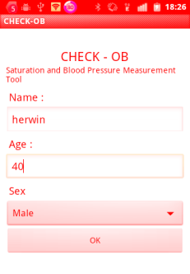

2. Display Connection To CHECK-OB

Before making measurements, must first Android smartphone connection with the CHECK-OB through blueetooth.

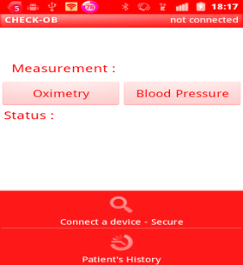

3. Display Menu Oximetry

This menu is to measure oximetry, patient first and then install the sensor on the finger after the ready button is pressed then Oximetry measurements began, the status of the process in writing. When you have finished, the measurement of the status will be OK and display the results of oximetry measurements.



4. Display Blood Pressure

This menu function is to measure the blood pressure of patients, the procedure to be followed is the patient must first install the cuff. The "OK" button to start the measurement, the status will be displayed, if the data is displayed, the status of "OK" Her sense of the data is valid. In case of measurement error, the status of "ERROR”.

5. Display send data to Email

If the patient independently wish to send data to a doctor or hospital, the patient can press the button then automatically email the measurement data will be sent via email. Requirement to send the data via email, android smartphone device must be connected to the internet via Wi-Fi or 3G GSM networks.



6. SMS Reception Results

Data sent via an SMS sent after the patient has been entered into the measurement. SMS is sent to a particular number is the number the doctor or hospital.

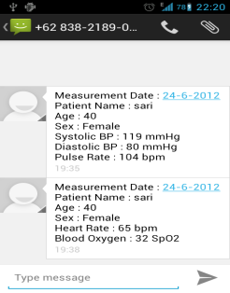

7. Results Acceptance E-mail

In addition to data sent SMS, measurement data can be sent via e-mail on the condition Android smartphone connected to the internet Wi-Fi or 3G GSM networks

**

4.1.2 Implementation of External Database (MySQL)

Implementation of an external database to store patient data carried the name, gender, age, data measurements. The database is placed in the server. Information provided in this database is general and confidential.

**4.2 Tests**

4.2.1 Testing a Bluetooth connection

The test is performed to retrieve the data reliability in connecting Bluetooth. The test is performed with a distance of 60 cm.

4.2.2 Testing Blood Pressure Measurement

Testing was conducted to determine how much reliability smartphone Android receive blood pressure data. Tests carried out 15 times.

4.2.3 Testing Oximetry Measurements

Testing was conducted to determine how much reliability Android smartphone receiving data oximetry. Tests carried out 15 times.

**4.3 Analysis of Test Results**

Analysis of the test results from both applications and hardware used in this study are already well underway in terms of the functionality of the application. Happens to the failure of data delivery due to shipping error by the microcontroller module so it can be in response to the Android smartphone.  
 Delivery of patient data using SMS is success, a failure can occur due to the condition of the network operator is used.  
 Overall Check-OB application can be run according to the design are made. Although this is only a prototype application and can’t be implemented in real time, but the works are implemented in accordance with the actual conditions.

V. CONCLUSION

Based on the testing that has been done in the previous chapter, some conclusions can be drawn as follows.

1. Prototypes that can work as planned that measure blood pressure and oximetry send data to the Android smartphone via Bluetooth.
2. The data is read in the Android smartphone can be sent via SMS method, e-mail and a local database.
3. From the results of the testing equipment there is still a failure of data transmission equipment after the measurement is completed, it is caused due to an error sending data to microcontroller module.
4. Application can be used for hospitals that have a local network so that after pengadakan patient data measurements by nurses, the data is stored directly in the database.
5. Applications can be used by patients with outpatient or hospital so that doctors easily monitor the progress of the patient's progress. Shipment data from patient can be via SMS and e-mail through the Internet.

ACKNOWLEDGMENT

Thanks to School of Electical Engineering and Informatics, Institut Teknologi Bandung as the organizers ICSET 2012 that has given us the opportunity to contribute.

ReferenceS

[1] Figueiredo, C., Nakamura, E., *Computação Móvel: Novas Oportunidades e Novos Desafios*. T&C Amazônia, 2003.

[2] Weiser, M., The Computer for the 21st Century, *In: Scientific American.* Volume: 265, Number: 3, Pages: 94-104, Februari, 1991.

[3] Vital Wave Consulting, *mHealth for Development: The Opportunity of Mobile Technology for Health care in the Developing World*. Washington, D.C. and Berkshire, UK: UN Foundation-Vodafone Foundation Partnership, 2009.

[5] Istepanean R., Laxminarayan S., Pattichis C. S., *M-Health Emerging Mobile Health Systems*, Springer Science, 2006.

[6] Hill, E. & Stoneham, MD., *Practical applications of pulse oximetry*, Oxford Radcliffe NHS Hospitals Headington, Oxford.

[7] Bailey, J., Fecteau, M., Pendleton, Noah L., *Wireless Pulse Oxymetri*, Worcester Polytechnic Institute, Amerika Serikat, 2008.

[8] Siyamta, Yamta, Pengantar Teknologi Bluetooth, 2008, <http://www.ilmukomputer.org/wp-content/uploads/2006/09/yamta-bluetooth.zip,12>, Juni 2012, 09.40 WIB.

[9] ______. *Android SDK Developer Guide*, http:developer.android.com.

[10] Murphy, Mark L., *Beginning Android 2*. United State of America : Apress, 2010.

[11] Hashimi, Sayed, Komatineni, Satya, MacLean, Dave, 2010. *Pro Android 2*. United State of America : Apress.

[12] Mednieks, Zigurd, Dornin, Laird, Meike , G. Blake & Nakamura, Masumi, *Programming Android*, O’Reilly, United State of America, 2011.

[13] _____, ,http://www.analog.com/library/analogDialogue/archives/41-01/pulse_oximeter.html. 15 Juni 2012.

[14] ______.http://www.dfrobot.com/. 14 April 2012.

[15] ____. <http://www.mysql.com/>. 30 Januari 2012.

[16] _____. <http://www.sqlite.org/>. 30 Januari 2012.